Install Ruby and DevKit

Step1) Got to <http://rubyinstaller.org/downloads/>

Download: [**Ruby+Devkit 2.6.5-1 (x64)**](https://github.com/oneclick/rubyinstaller2/releases/download/RubyInstaller-2.6.5-1/rubyinstaller-devkit-2.6.5-1-x64.exe)

**Step 2)** Open the downloaded file.

* 1. Accept license
  2. Click on Next button

**Step 3)** In next screen.

1. Select your Installation Directory
2. Select all Options

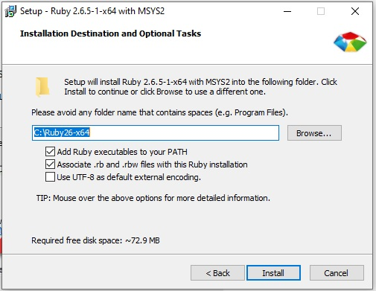

1. Click Install

**Step 4)** In the following screen, Click on Next

**Step 5)** Wait for installation to complete.

**Step 6)** Click Finish

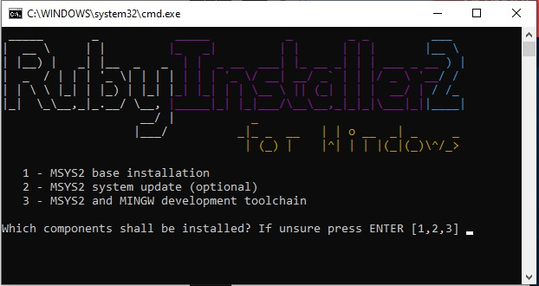

**Step 7)** Once installation is complete, Lets Run Ruby! Enter [1]. Close cmd.

**Step 8)**  Start Command prompt with Ruby:

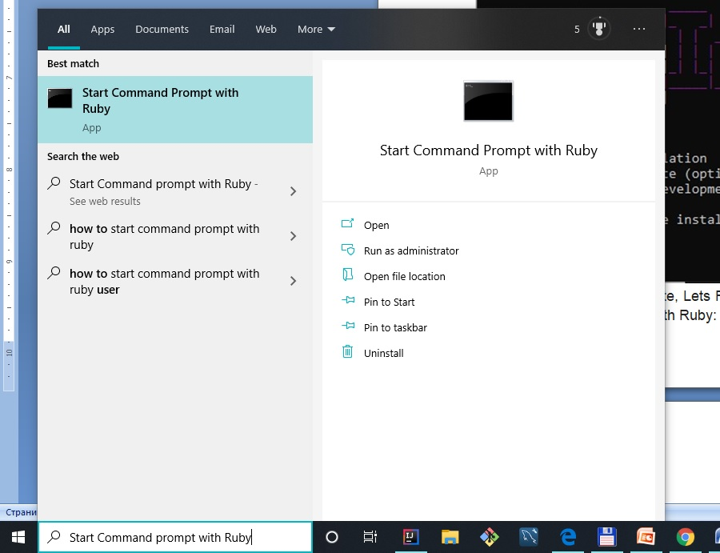

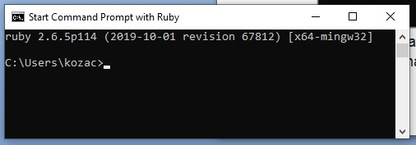

Install Cucumber

**Step 1)** Type in Ruby cmd "gem install cucumber".

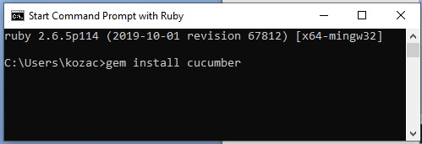

Enter.

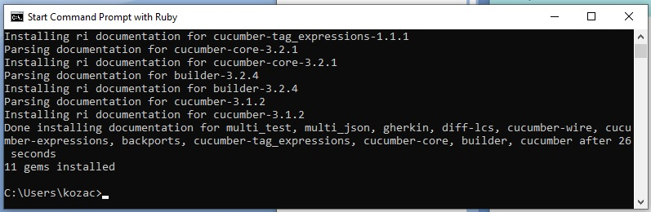

**Step 2)** To verify cucumber is installed successfully or not just type "cucumber --version". Enter.

C:\Users\kozac>cucumber -version

*** WARNING: You must use ANSICON 1.31 or higher (https://github.com/adoxa/ansicon/) to get coloured output on Windows

Code:

* features/support/env.rb

Features:

0 scenarios

0 steps

0m0.000s

C:\Users\kozac>

### [How to install ansicon for cucumber to get coloured output on Windows](https://qastuffs.blogspot.com/2011/02/how-to-install-ansicon-for-cucumber-to.html)

<https://qastuffs.blogspot.com/2011/02/how-to-install-ansicon-for-cucumber-to.html>

The steps on how to install ansicon.exe:

1. Download and unzip the file from <https://github.com/adoxa/ansicon/downloads> <https://github.com/adoxa/ansicon>

ANSICON release v.1.89:

2. Unzip folder ansi189-bin.zip in the **ansi189-bin** folder. Open PowerShell under x64 folder (Shift+right-click the folder and select "Open PowerShell window here").

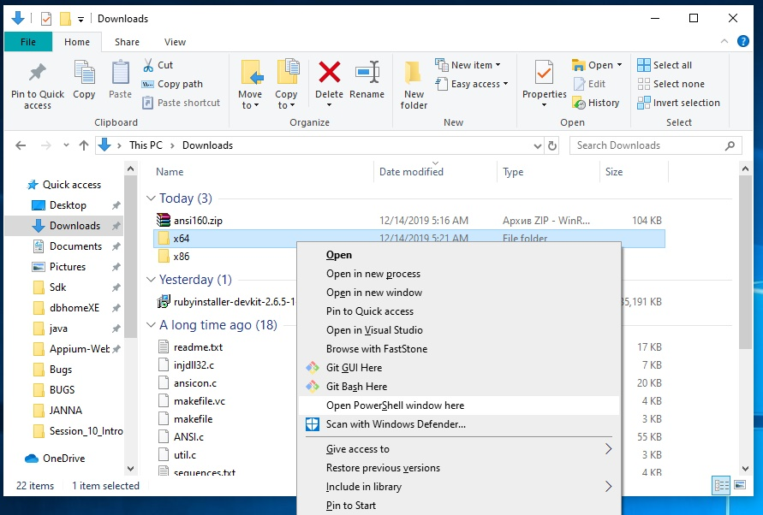

3. Type < **.\ansicon.exe -i** > − Enter and you will get the following:

PS D:\ONLINE_November-11-2019\CUCUMBER\ansi189-bin\x64> .\ansicon.exe

Microsoft Windows [Version 10.0.18362.535]

(c) 2019 Microsoft Corporation. All rights reserved.

D:\ONLINE_November-11-2019\CUCUMBER\ansi189-bin\x64>.\ansicon.exe -i

D:\ONLINE_November-11-2019\CUCUMBER\ansi189-bin\x64>

4. Now, you won’t get Warning message (Search "ruby" – Start Command Prompt with Ruby – Paste: "cucumber --version" - Enter).

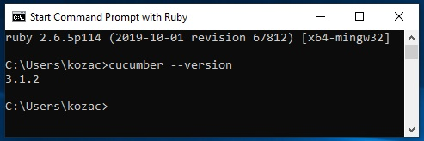

Install IDE RubyMine

<https://www.jetbrains.com/ruby/download/#section=windows>

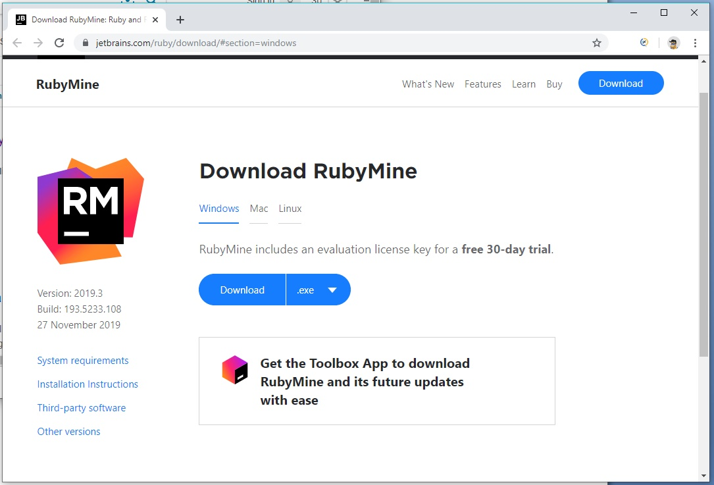

Download

Run RubyMine-2019.3.exe

Next

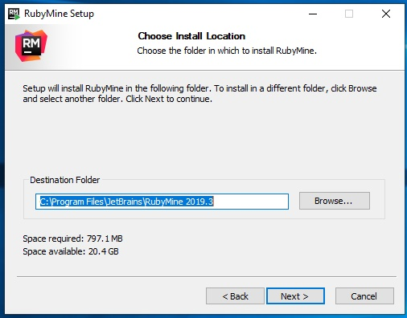

Next

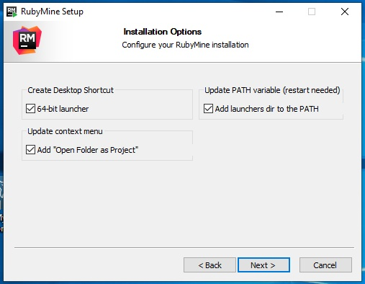

Next

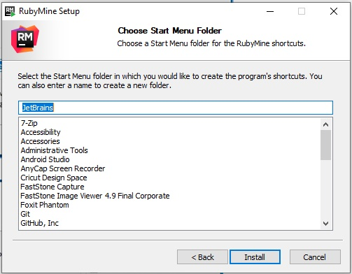

Install

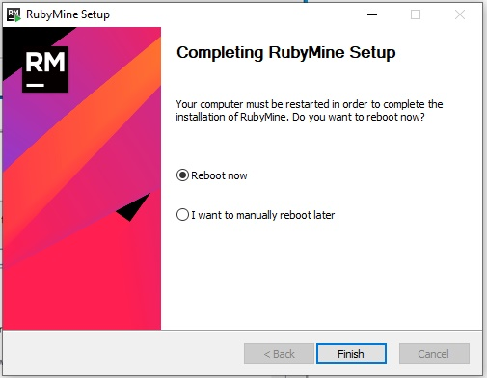

Finish

Reboot

Run shortcut: JetBrains RubyMine 2019.3 x64

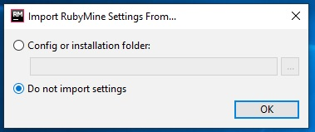

OK

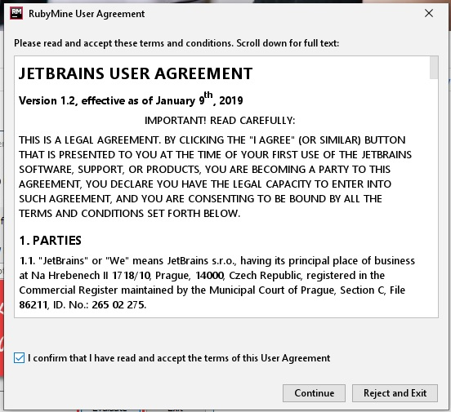

Confirm and Continue

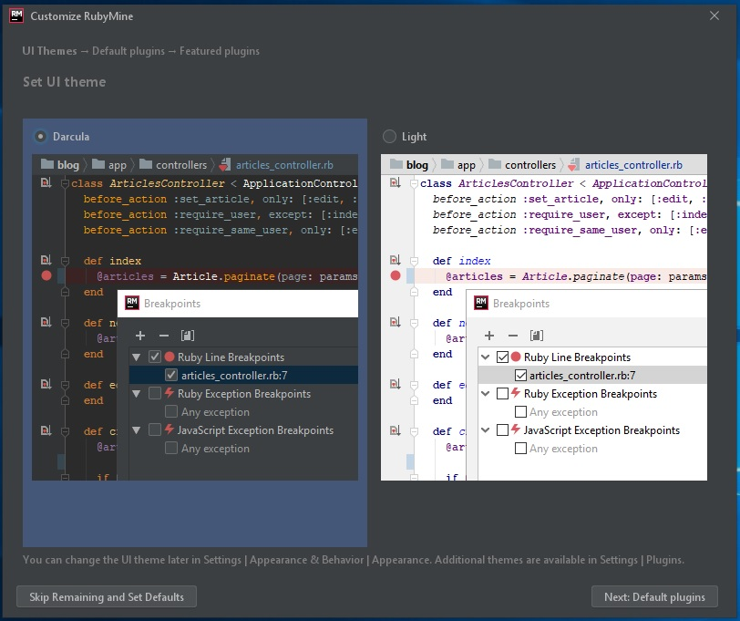

…Set Defaults

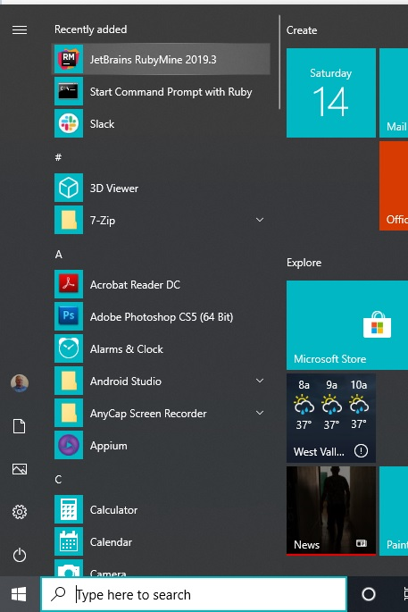

Open RubyMine:

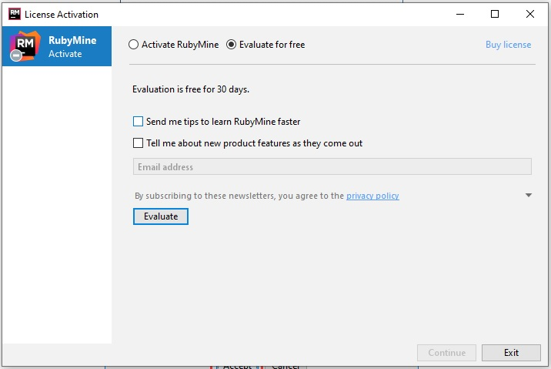

Evaluate. Close.

Open RubyMine:

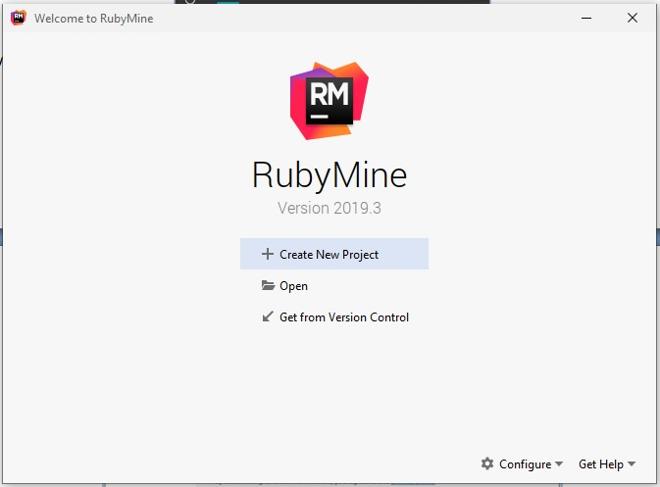

Install watir-webdriver

**Step 1)** Click on "Start Command Prompt With ruby" and install command "gem install watir-webdriver"

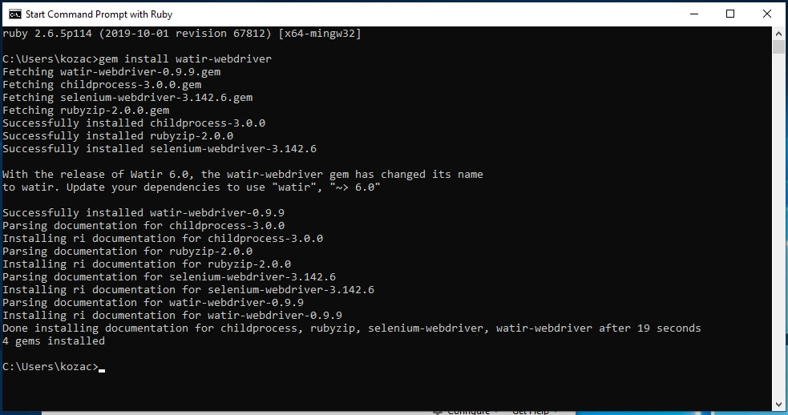

- watir-webdriver installed successfully.

First Cucumber Script

**Step 1)** Open RubyMine Editor

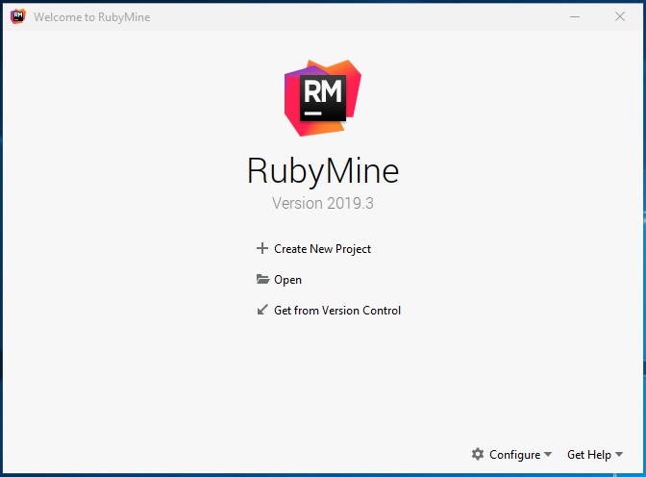

**Step 2)** Create a new project: CucumberFirstMyProject;

Add Ruby SDK: ruby-2.6.5-p114 (C:\Ruby26-x64\bin\ruby.exe)

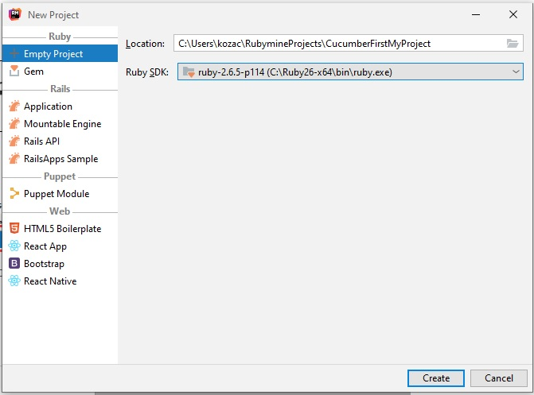

Create

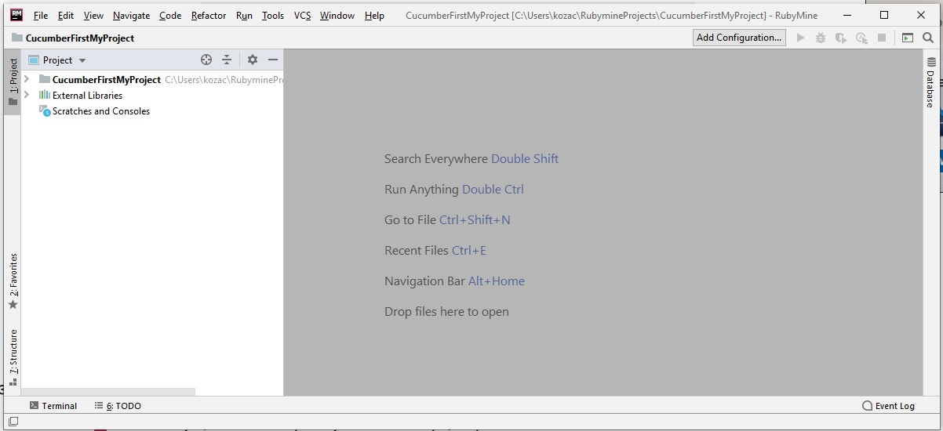

**Step 3)**create a file directory "features"

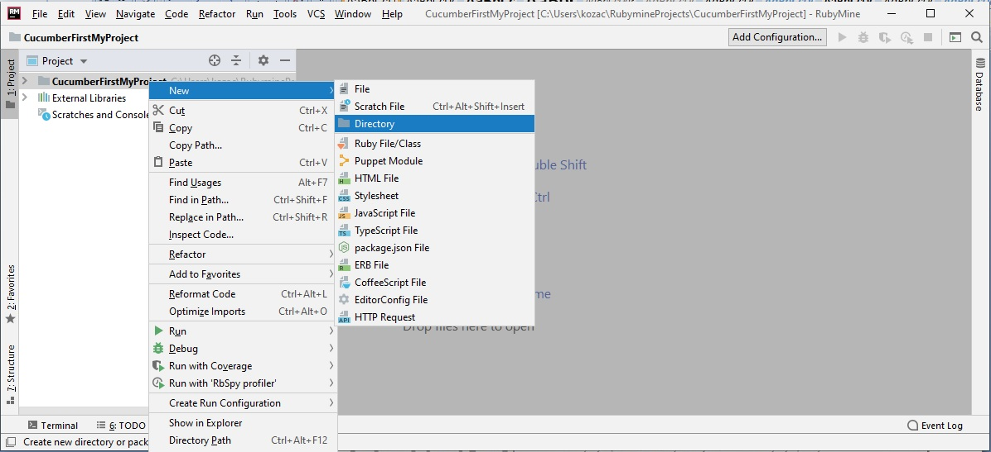

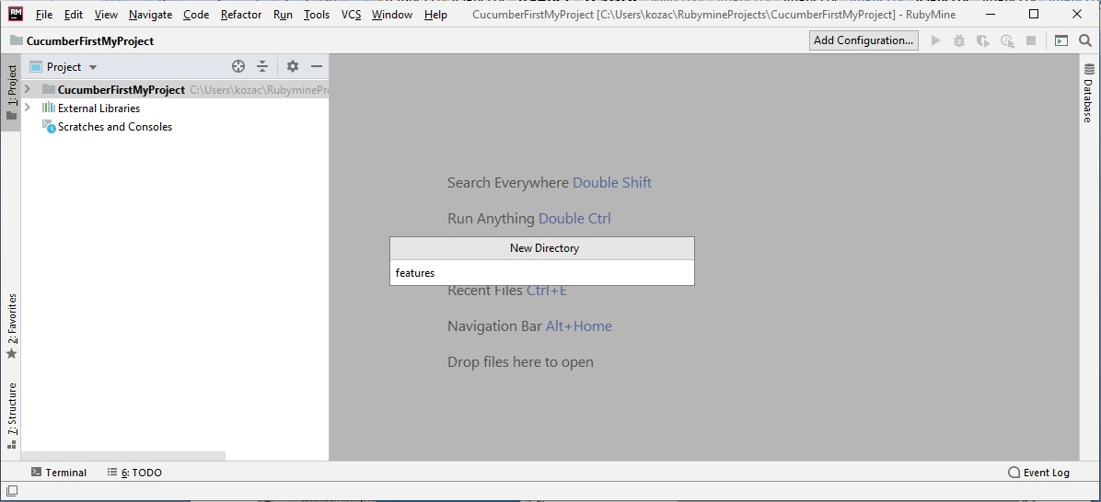

Enter

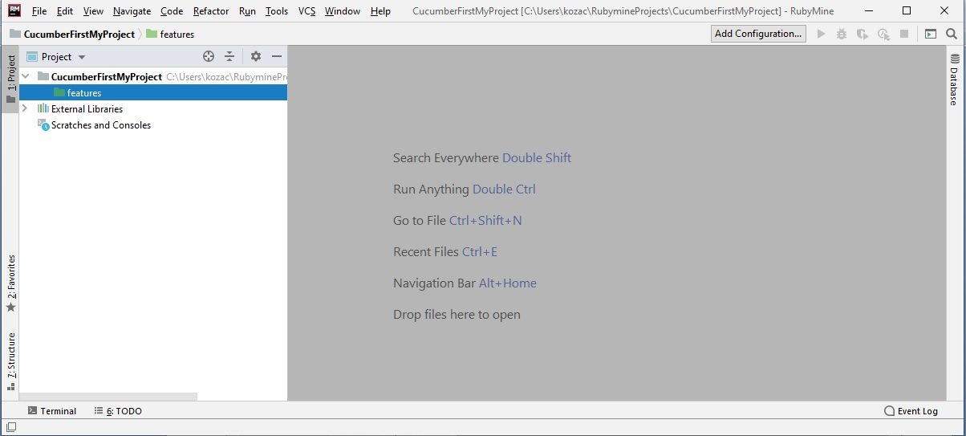

**Step 4)** create and Save File in "CucumberFirstMyProject/features/" with name "multiplication.feature"

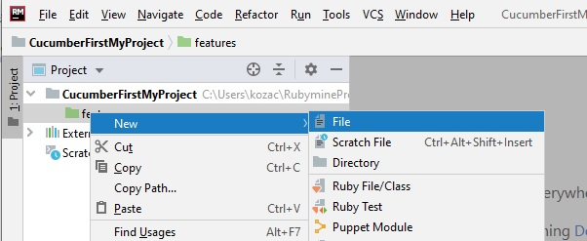

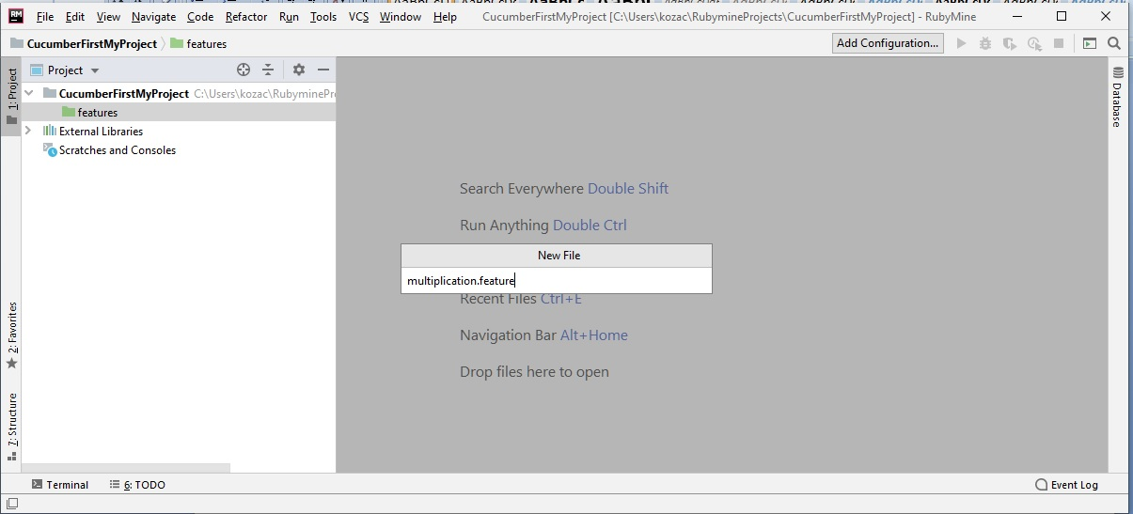

Enter

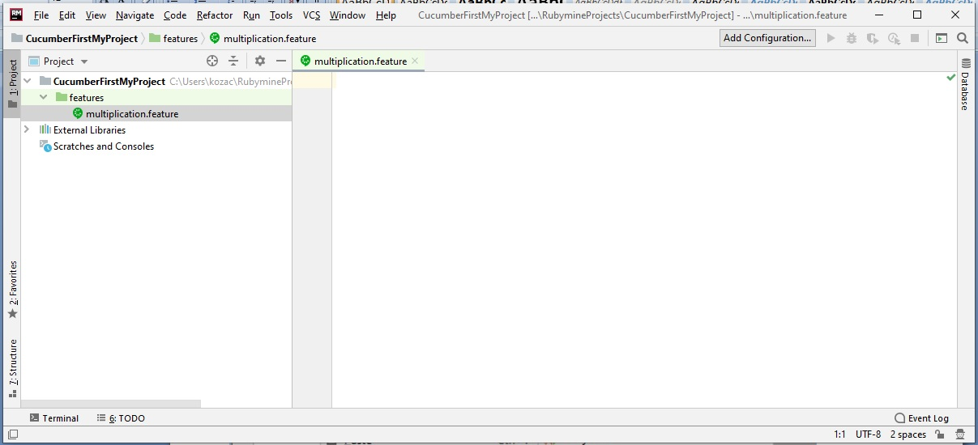

**Step 5)** To execute our scenario, save the following commands in the Feature File

Feature: Multiplication

I multiply two numbers

Scenario: multiply a and b

Given I have variable a

And I have variable b

When I multiplication a and b

Then I display the Result

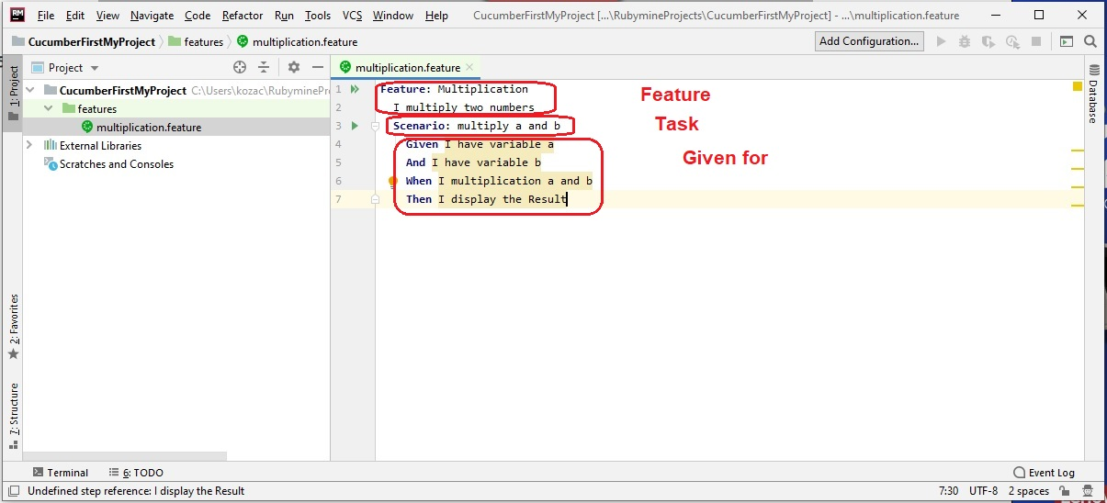

**Save all.**

**Step 6)**  Run our First feature file.

Open PowerShell under the folder C:\Users\kozac\RubymineProjects.

Run command: cucumber CucumberFirstMyProject\features\multiplication.feature

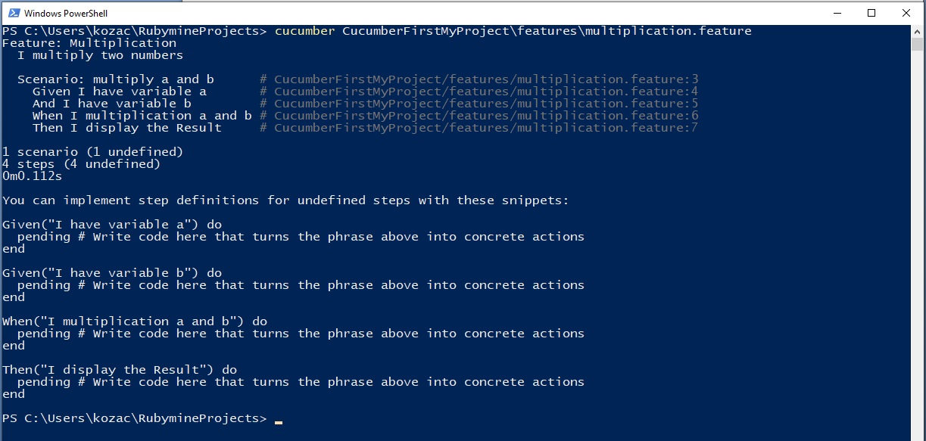

**Step 7)** Lets create step definition file for our Feature File!

Create a new directory (folder step_definition) in Rubymine editor

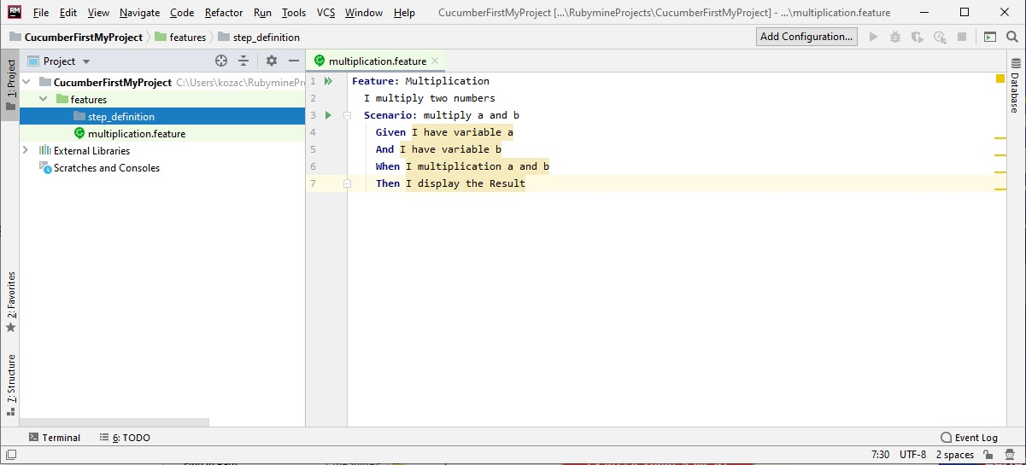

**Step 8)** Create new step file in "//features/step_definititons" with name multiplication.rb

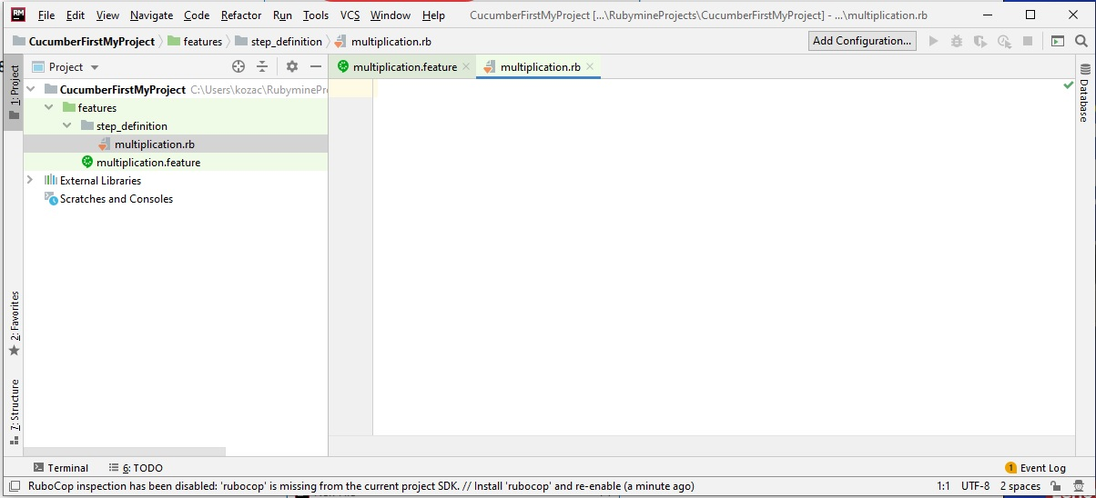

**Step 9)** Write the following code into the step file:

Given(/^I have variable a$/) do

@a = 50

end

And(/^I have variable b$/) do

@b = 70

end

When(/^I multiplication a and b$/) do

@mul = @a * @b

end

Then(/^I display the Result$/) do

puts "Multiplication of #{@a} and #{@b} is #{@mul}"

end

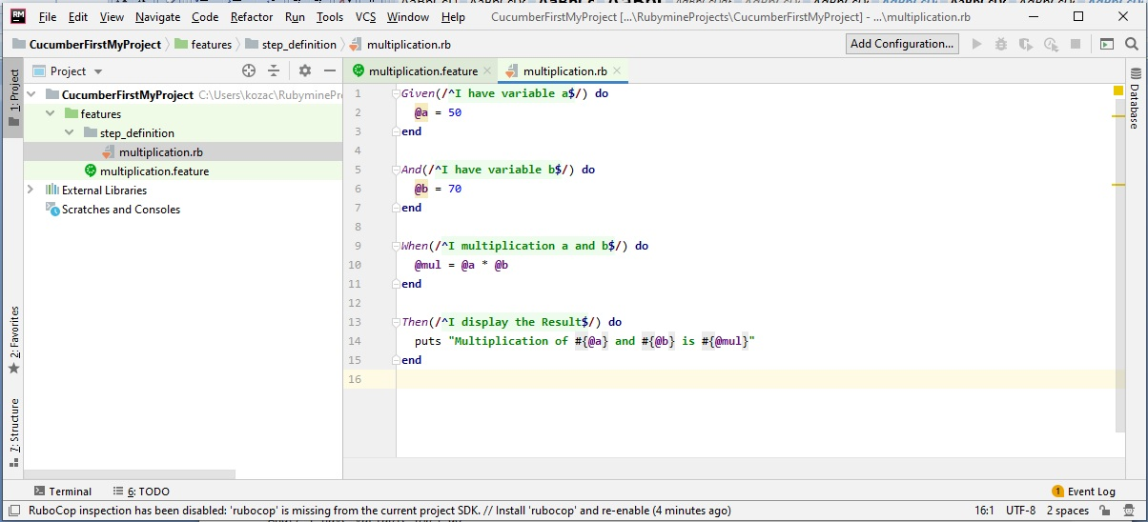

**Step 10)**  Run our multiplication.feature file again:

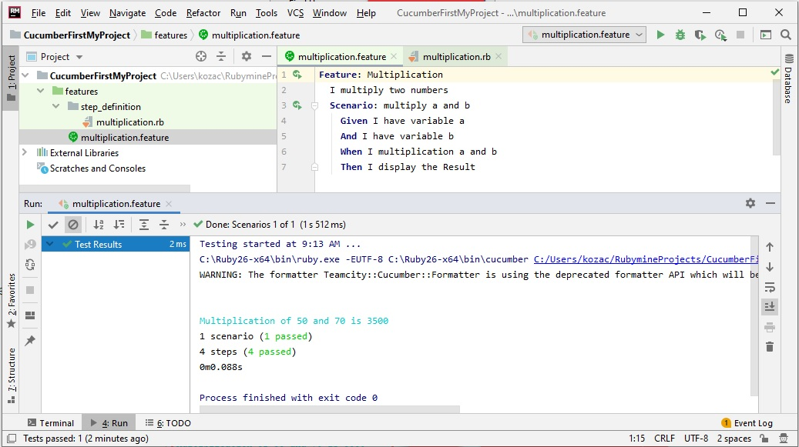

Scenario passed successfully with result.